EXERCISE 6.2

Question 1:

In the given figure (i) and (ii), DE || BC. Find EC in (i) and AD in (ii).

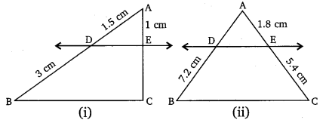

Solution:

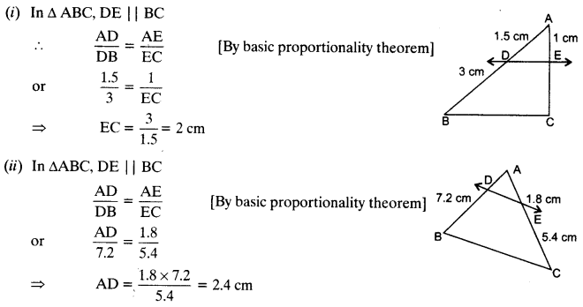

Question 2:

E and F are points on the sides PQ and PR respectively of a ∆PQR. For each of the following cases, state whether EF || QR:  
(i) PE = 3.9 cm, EQ = 3 cm, PF = 3.6 cm and FR = 2.4 cm  
(ii) PE = 4 cm, QE = 4.5 cm, PF = 8 cm and RF = 9 cm  
(iii) PQ = 1.28 cm, PR = 2.56 cm, PE = 0.18 cm and PF = 0.36 cm

Solution:

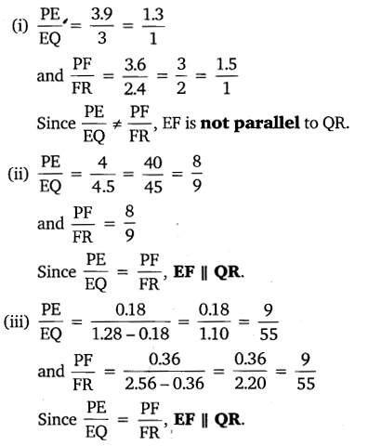

Question 3:

In the given figure, if LM || CB and LN || CD.  
Prove that AM/AB=AN/AD∙  
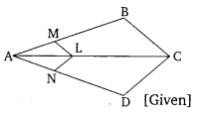

Solution:

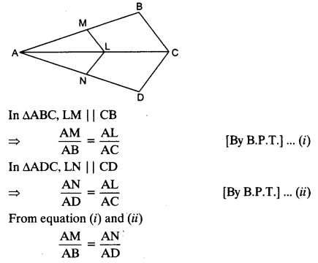

Question 4:

In the given figure, DE || AC and DF || AE.  
Prove that BF/FE=BE/EC∙  
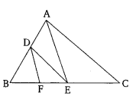

Solution:

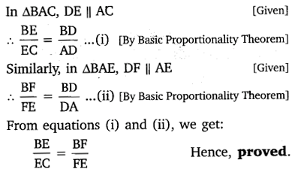

Question 5:

In the given figure, DE || OQ and DF || OR. Show that EF || QR.  
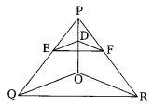

Solution:

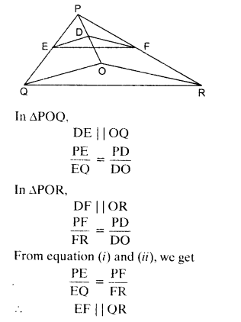

Question 6:

In the given figure, A, B and C are points on OP, OQ and OR respectively such that AB || PQ and AC || PR. Show that BC || QR.  
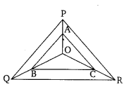

Solution:

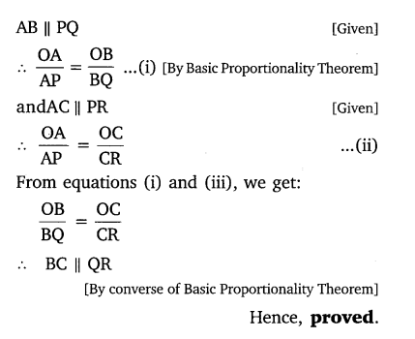

Question 7:

Using B.P.T., prove that a line drawn through the mid-point of one side of a triangle parallel to another side bisects the third side. (Recall that your have proved it in class IX)

Solution:

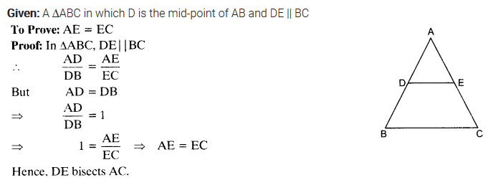

Question 8:

Using converse of B.P.T., prove that the line joining the mid-points of any two sides of a triangle is parallel to the third side.  (Recall that your have done it in class IX)

Solution:

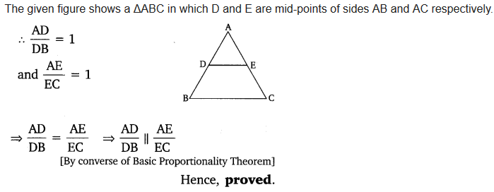

Question 9:

ABCD is a trapezium in which AB || DC and its diagonals intersect each other at the point O. Show that AO/BO=CO/DO∙

Solution:

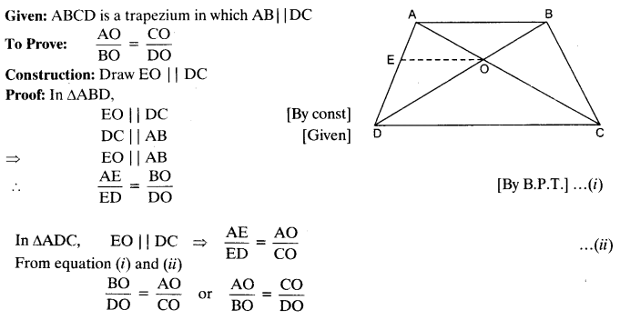

Question 10:

The diagonals of a quadrilateral ABCD intersect each other at the point O such that AO/BO=CO/DO∙ Show that ABCD is a trapezium.

Solution:

